**Practical No 2**

**Aim:** Create Data Source using SSAS(SQL Server Analysis Services.)

**Solution:**

Open Application -> Microsoft SQL Server 2008 R2 -> SQL Server

Business Intelligence Development Studio

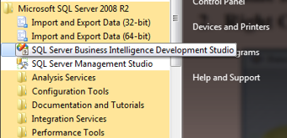

1. Select File -> New Project -> Choose Analysis Service Project ->

Name it as “SalesProduct_BIPrj” and click on OK.

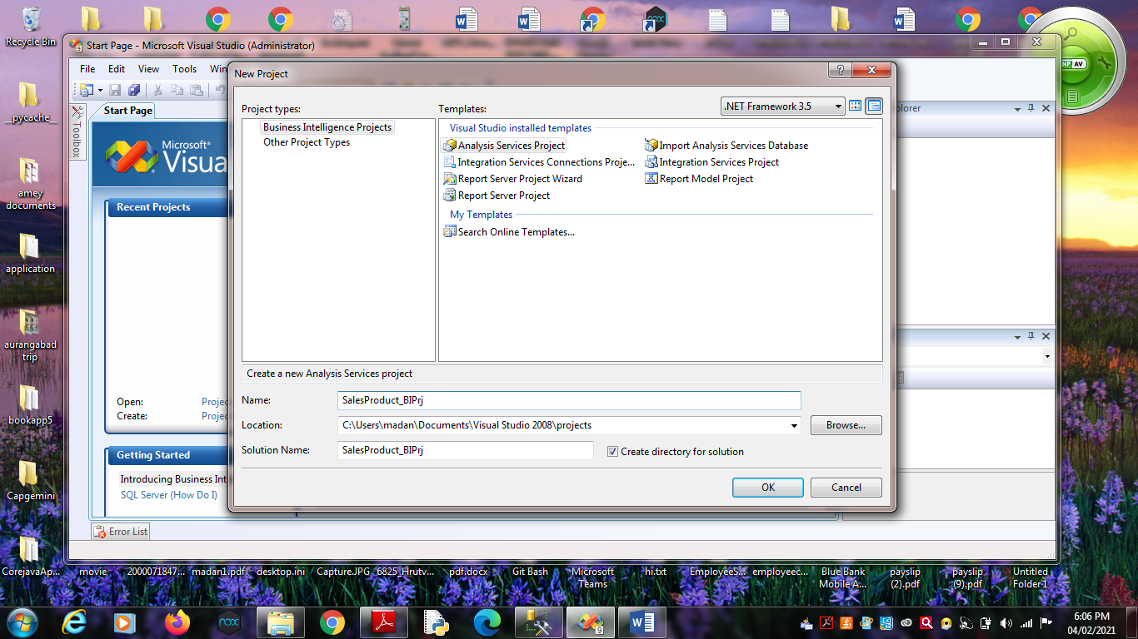

2. Right Click on Data Sources -> New Data Source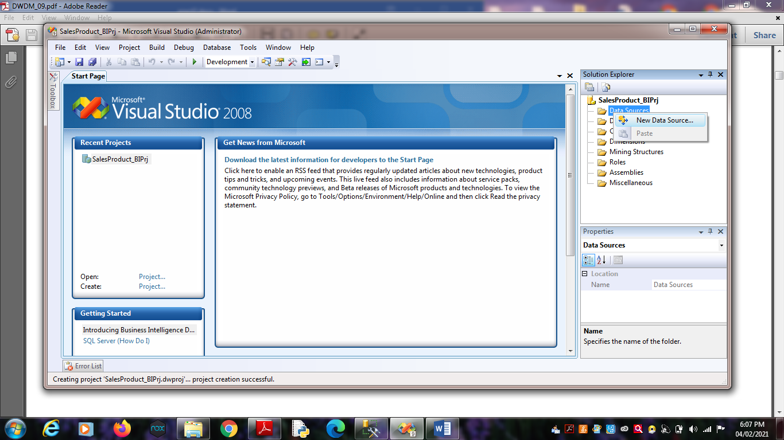

Click on Next.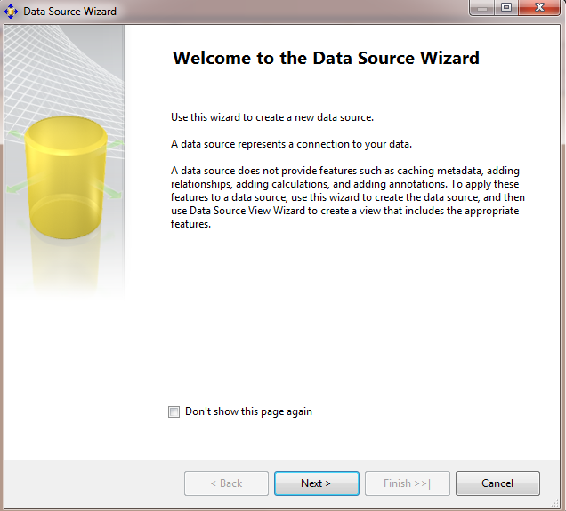

3. Choose Provider as “Microsoft OLEDB Provider for SQL Server” ,

Server Name as “.”, Select database name as

“SalesProduct”.(Created in SQL Server Management studio).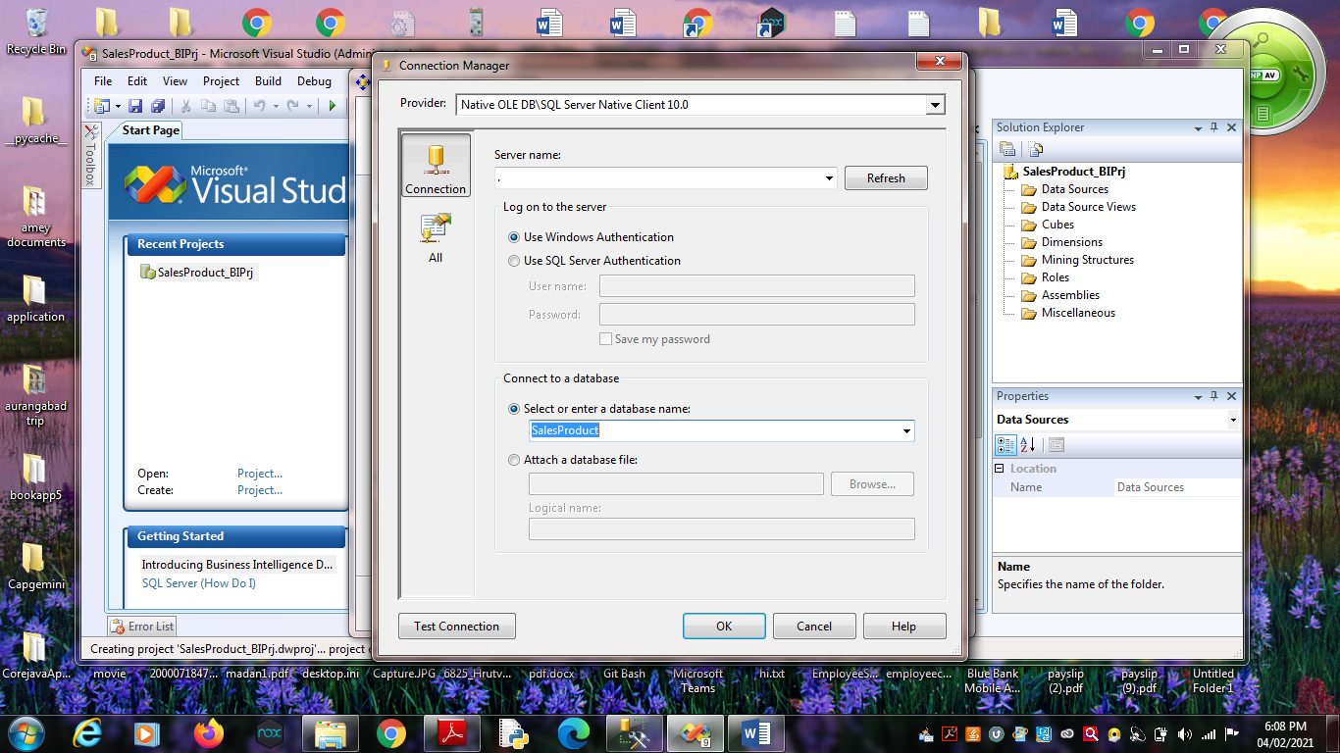

Click on Next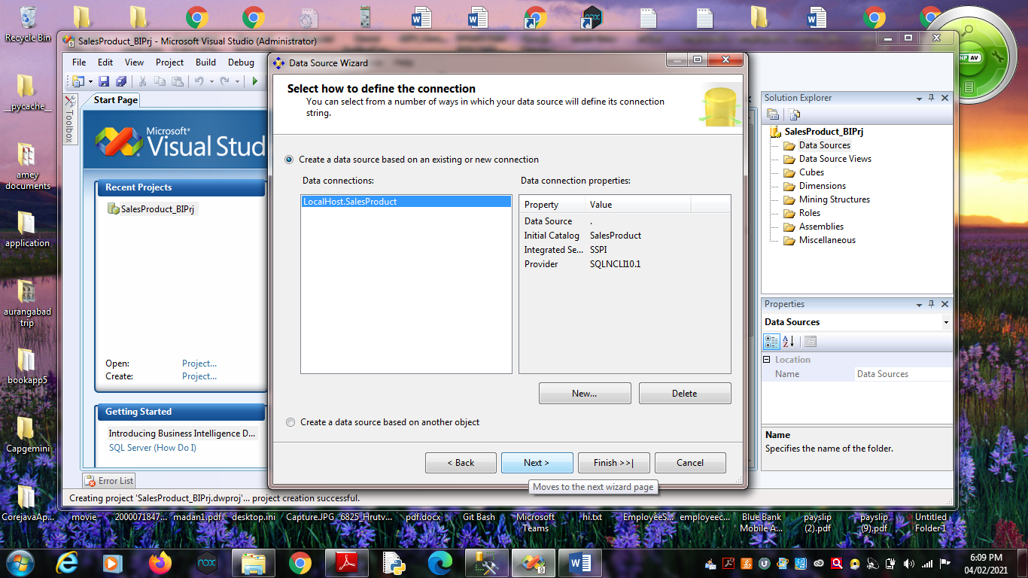5. Choose “Inherit” option.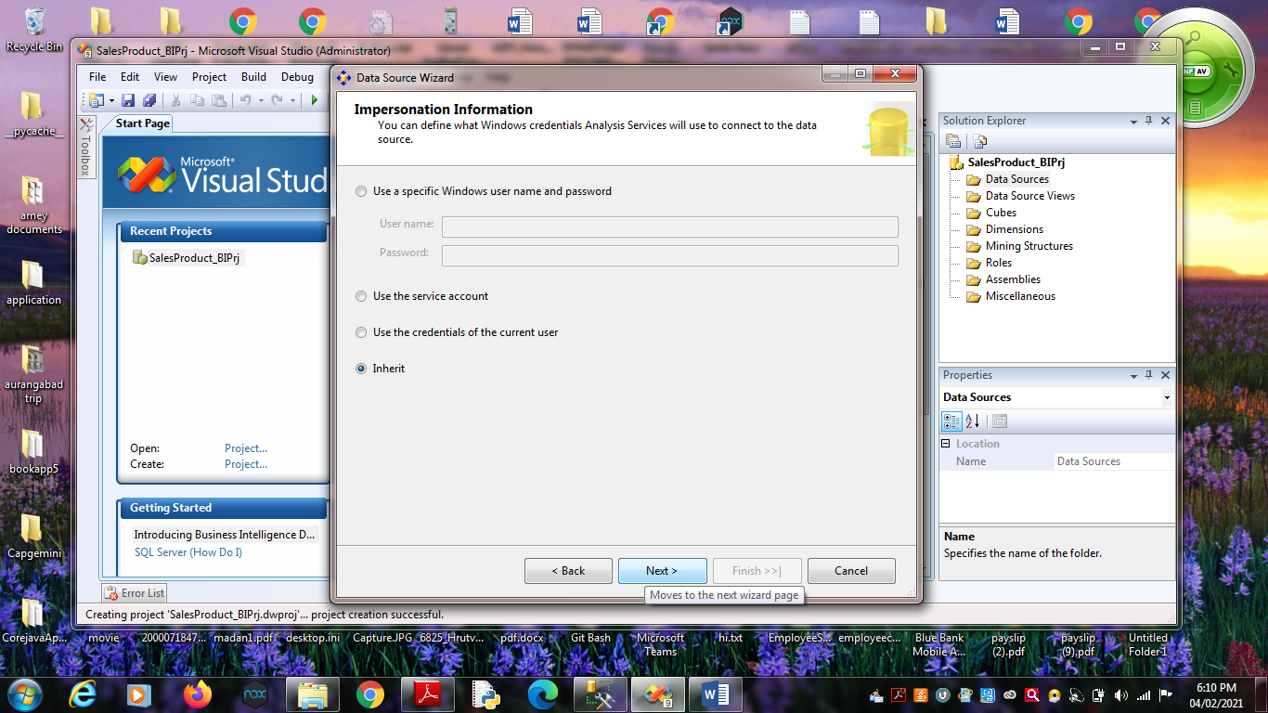 Click on Next.

6. Click on Finish.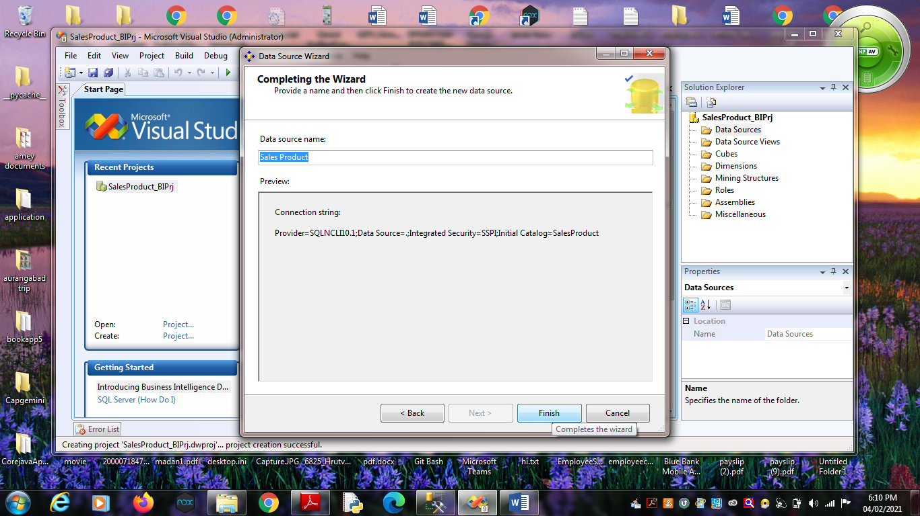

Name Data Source as “Sales Product”.